CORE FUNCTIONAL (LEVEL 2)
- Test Suites
- Test Case Structure
- Creating Test Cases
- Test Case Templates
- Test Case Fields (Default Fields)
- Custom Fields in TestRail
- Organizing Test Cases (Folders & Suites)

1. Test Suites :
A Test Suite is a logical collection of test cases. It is like a folder for test cases, grouped by:
- Feature
- Module
- Functionality
Test suites matter because :
- Better organization
- Selective execution
- Easier regression planning
- Scales to large projects
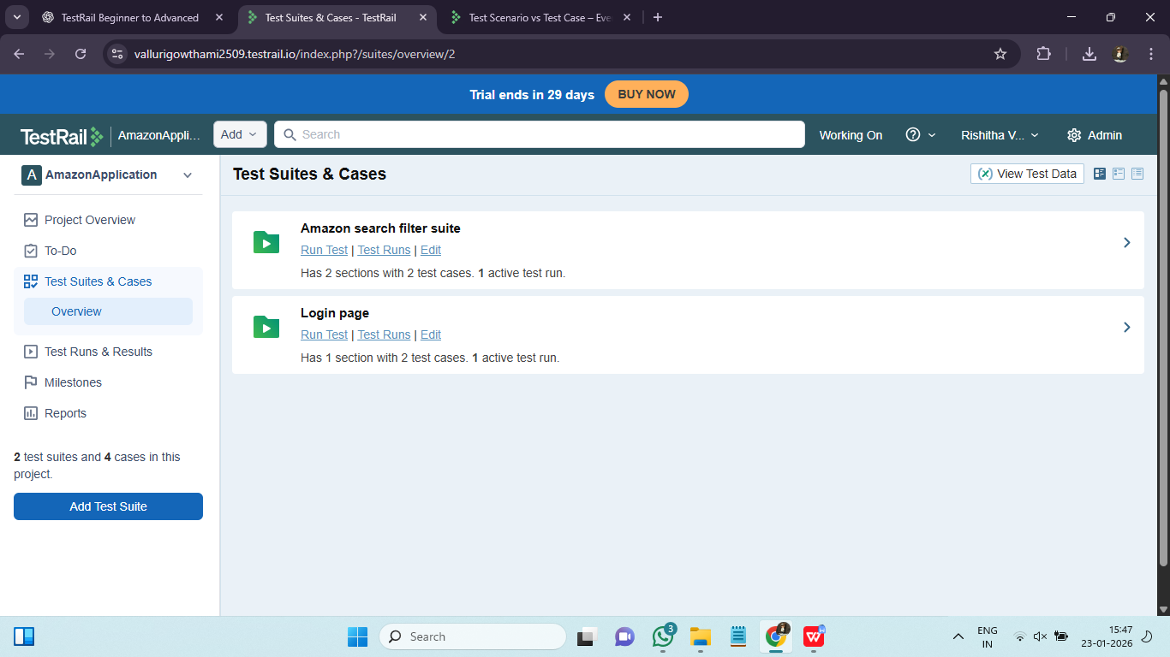

2. Test Case Structure :
A Test Case is a documented scenario that verifies a requirement. A standard test case structure is :
Section | Purpose
Title | What is being tested
Preconditions | Setup needed
Steps | Actions
Expected Result | Expected outcome

3. Creating Test Cases :
Test cases can be created manually through the UI or imported using CSV/XML. Best practices include clear naming, atomic steps, and precise expected outcomes.
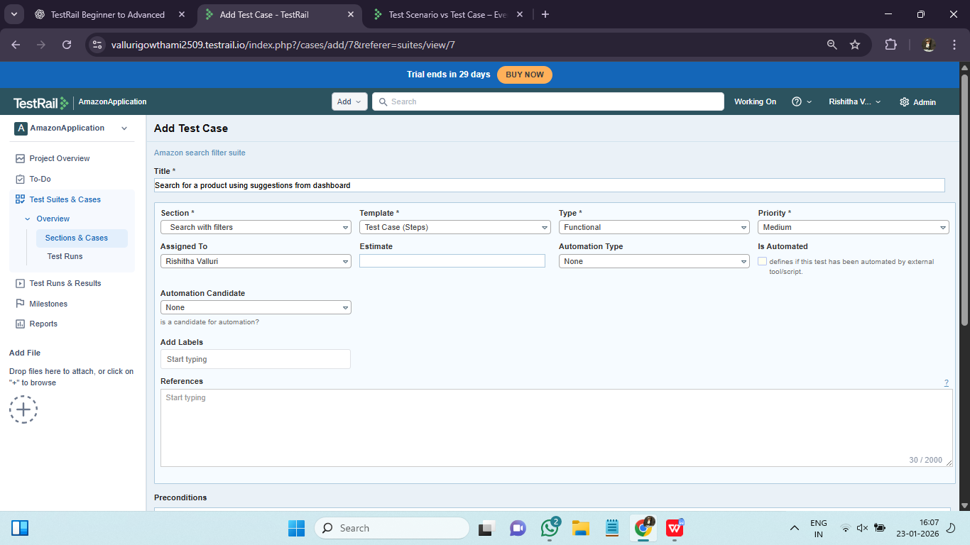

Test Case Templates :

A Test Case Template defines:
- Structure
- Fields
- Layout of test cases
Templates enforce quality and uniformity in test design.

Default Templates :
- Test Case (Text)
- Test Case (Steps)

Why Templates Matter :

Consistency across team

Different testing styles

Standardization

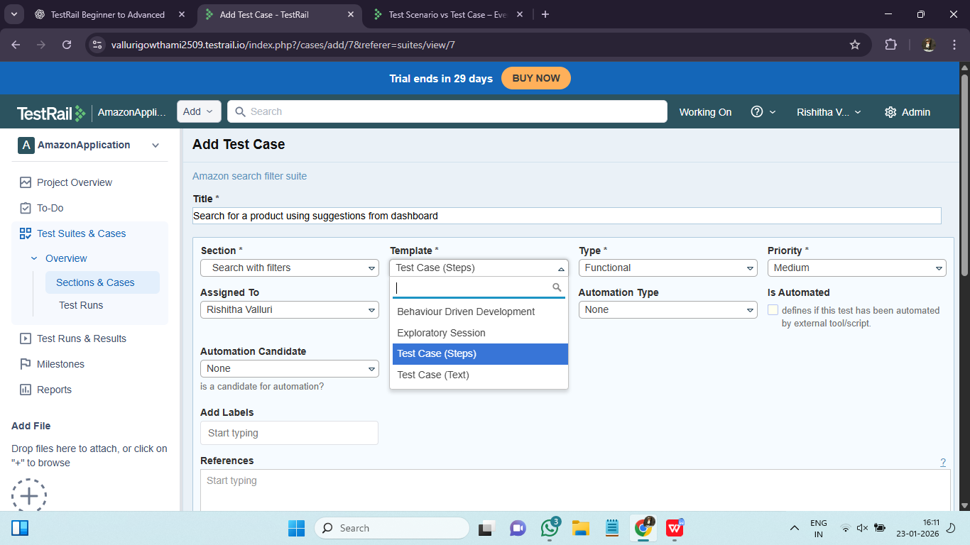

5. Test Case Fields (Default Fields) :
Default fields capture essential information. Fields are attributes of a test case.
Common Default fields are :
Field | Purpose
Title | Test case name
Section | Location
Priority | Importance
Type | Functional / Regression
Preconditions | Setup
Steps | Actions
Expected Result | Outcome

6. Custom Fields in TestRail :
Custom fields exists because every project has unique needs like:
- Automation status
- Requirement ID
- Browser
- Environment
Custom fields enable traceability and automation alignment.
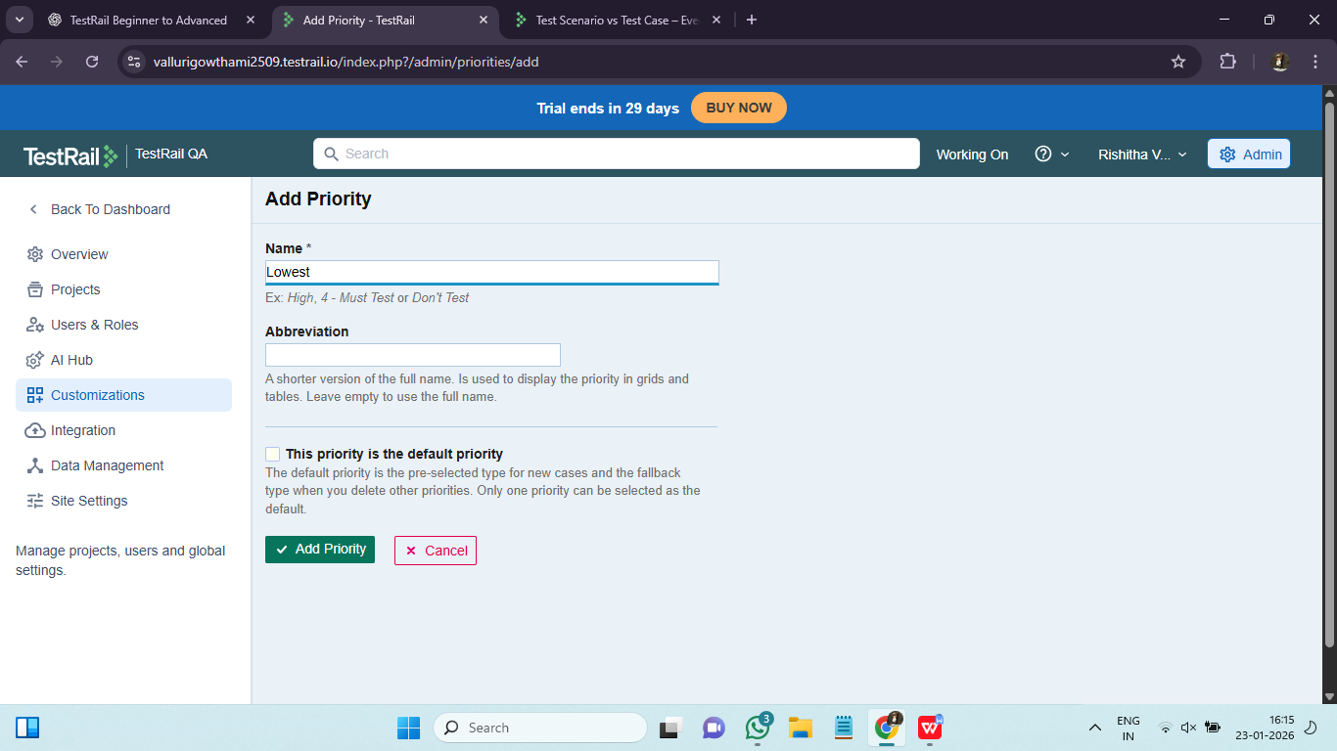

7. Organizing Test Cases (Folders & Suites) :
Sections (folders) within Suites help organize test cases hierarchically. Proper organization improves scalability and maintainability. Proper organization reduces execution time and improves regression efficiency.

